**PROJECT REPORT**

**ON**

**Freshop – Online Vegetable and grocery Store**

**Carried Out at**



## Institute for Advanced Computing & Software Development

**Akurdi, PUNE**

**UNDER THE SUPERVISION OF**

**Mr. HARSHAL Sir and Mrs. MONIKA ma’am**

**IACSD Pune**

**Submitted By**

**Sharma Ganesh Vinod (230341220169)**

**Swapnil Kumar Tamrakar (230341220206)**

**PG DIPLOMAA IN ADVANCED COMPUUTING,**

**IACSD , PUNE**

**CANDIDATE’S DECLARATION**

We hereby certify that the work being presented in the report entitled **Freshop-Online vegetable and grocery app**, in partial fulfilment of the requirements for the award of PGDiploma Certificate and submitted in the department of PG-DAC of the IACSD, is an authentic record of our work carried out during the period, 1st August 2023 to 31st August 2023 under the supervision of **Mr. Harshal and Mrs. Monika,** IACSD,Akurdi Pune. The matter presented in the report has not been submitted by us for the award of any degree of this or any other Institute/University.

**(Name and Signature of Candidate)**

SHARMA GANESH VINOD (230341220169)

**Counter Signed by**

-----------------------------

SWAPNIL KUMAR TAMRAKAR(230341220206)

**Counter Signed by**

--------------------

**ACKNOWLEDGMENT**



We take this opportunity to express our gratitude to all those people who have been directly and indirectly with us during the competition of this project. We pay thanks to Mr. Harshal Sir and Monika ma’am who has given guidance and a light to us during this major project. His versatile knowledge about this project has eased us in the critical times during the span of this Final Project. We acknowledge here out debt to those who contributed significantly to one or more steps. We take full responsibility for any remaining sins of omission and commission.

Sharma Ganesh Vinod (230341220169)

Swapnil Kumar Tamrakar (230341220206)

**CERTIFICATE**



This is to certify that the work titled **Freshop – Fresh Vegetable and grocery app** is carried out by Sharma ganesh vinod (230341220169), Swapnil Kumar Tamrakar (230341220206) bonafide students of **IACSD** Akurdi from 1st August 2023 to 31st August 2023. The Course End Project work is carried out under my direct supervision and 80% completed.

**Mr. Harshal and Mrs. Monika**

Name of Supervisor

IACSD (C-DAC #230), Akurdi ,

Pune - 411044, India

**ABSTRACT**



The aim of this project is to develops an online vegetable and grocery store app. The system is an online application that can be accessed throughout the organization and outside as well with proper login provided. This system can be used for ordering vegetables and groceries online. User sign ups and create there profile. Suppliers can also login may also access/search any information put up by Customers. The project has been planned to be having the view of distributed architecture, with centralized storage of the database. The application for the storage of the data has been planned. Using the constructs of MySQL Server and all the user interfaces have been designed using the Java Spring boot technologies. The database connectivity is planned using the “SQL Connection” methodology. The standards of security and data protective mechanism have been given a big choice for proper usage. The application takes care of different modules and their associated reports, which are produced as per the applicable strategies and standards that are put forwarded by the administrative staff.

**TABLE OF CONTENT**



**CHAPTER 1. INTRODUCTION**

1.1 Purpose

1.2 Product scope

1.3 Definitions

1.4 Overview

**CHAPTER 2. Overall Description**

2.1 Product Perspective

2.2 Product Functions

2.3 User Characteristics

2.4 Principle Actors

2.5 General Constraints

**CHAPTER 3. SOFTWARE REQUIREMENT SPECIFICATION**

3.1 Functional Requirement

3.2 Non-Functional Requirements

3.3 Performance Requirements

**CHAPTER 4. INTERFACE REQUIREMENT**

4.1 Software I/F

4.2 Hardware I/F

**CHAPTER 5. Architecture Design**

5.1 DFD

5.2 Model design

**CHAPTER 6. UML DIAGRAM**

**CHAPTER 7. CONCLUSION**

**CHAPTER 8. REFERENCES**

**CHAPTER 1**

**INTRODUCTION**



As we know that searching of fresh vegetables in market takes quite a long time and some times we even need to suffice with what is available near by . So , With the help of this web application customers can search and order wide range of fresh vegetable/fruits/groceries just with a click.

**1.1 Purpose**

This document is meant to delineate the features of OSS, so as to serve as a guide to the developers on one hand and a software validation document for the prospective client on the other.

The Online Shopping System (OSS) for Fresh vegetable and grocery item shop web application is intended to provide complete solutions for vendors as well as customers through a single gate way using the internet .

It will enable vendors to setup online shops , customers to browse through the shop and purchase them

online without having to visit the shop physically. The administration module will enable a system administrator to approve and reject requests for new shops and maintain various lists of shop category.

**1.2 Product Scope**

This system allows the customer’s to maintain their cart for add or remove the product over the internet.

**1.3 Definitions**:

OSS- Online shopping System (for Vegetable and grocery shop)

SRS- Software Requirement Specification

GUI- Graphical User Interface

Stakeholder- The person who will participate in system

Ex. Customer, Administrator, Visitor etc.

**1.4 Overview:**

This system provides an easy solution for customers to buy the product without going to the shop and also to shop owners to sell their products.

This proposed system can be used by any naïve users and it does not require any educational level , experience or technical expertise in computer field but it will be of good use if user has the good knowledge of how to operate a computer.

**CHAPTER 2**

**Overall Description**



The Online Shopping system (OSS) application enables vendors to set up online shops, customers to browse through the shops, and a system administrator to approve and reject requests for new shops and maintain lists of shop categories.

Also the developer is designing an online shopping site to manage the items in the shop and also help customers to purchase them online without visiting the shop physically .

The online shopping system will use the internet as the sole method for selling goods to its consumers.

**2.1 Product Perspective:**

This product aimed toward a person who don’t want to visit the shop as he might not have time or

might not be interested in visiting there and dealing with lot of formalities.

**2.2 Product Functions:**

OSS should support this use case:

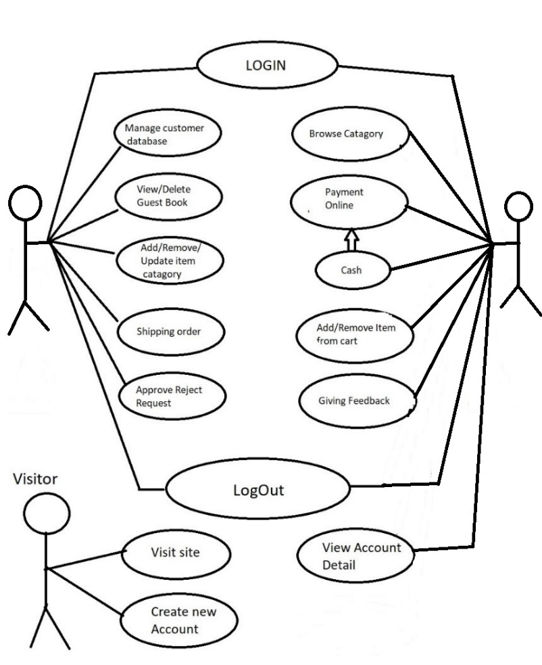

**2.3 User Characteristics:**

User should be familiar with the terms like Login , register , order system etc.

**2.4 Principle Actors:**

Three principle Actors are Supplier , Customer and Administrator.

**2.5 General Constraints:**

A full internet connection is required for OSS.

**2.6 Assumptions and Dependencies :**

Working of OSS need Internet Connection.

**CHAPTER 3**

**SOFTWARE REQUIREMENT SPECIFICATION**



**3.1 Functional Requirements:**

This section provides requirement overview of the system.

Various functional modules that can be implemented by the system will be –

**3.1 Description:**

**3.1.1 Registration**

If customer wants to buy the product then he/she must be registered, unregistered user can’t go to the shopping cart.

**3.1.2 Login**

Customer an login to the system by entering valid user id and password for the shopping app.

**3.1.3 Changes to Cart**

Changes to cart means the customer after login or registration can make order or cancel order of the product from the shopping cart.

**3.1.4 Payment**

In this system we are dealing the mode of payment by Cash .We will extend this to credit card ,debit card etc in the future.

**3.1.5 Logout**

After ordering or surfing for the product customer can logout.

**3.1.6 Report Generation**

After ordering for the product ,the system will sent one copy of the bill to the customer’s Email-address and another one for the system data base.

**3.2 Non-Functional Requirements:**

Following Non-Functional Requirements will be there in the App:

(i) Secure access to consumer’s confidential data.

(ii) 24X7 availability.

(iii) Better component design to get better performance at peak time.

(iv) Flexible service based architecture will be highly desirable for future extension .Non-Functional Requirements define system properties and constraints.

Various other Non-Functional Requirements are:

* Security

* Reliability

* Maintainability

* Portability

* Extensibility

* Reusability

* Compatibility

* Resource Utilization

**3.3 Performance Requirements:**

In order to maintain an acceptable speed at maximum number of uploads allowed from a particular customer as any number of users can access to the system at any time.

Also the connections to the servers will be based on the attributes of the user like his location and server will be working 24X7 times.

**3.4 Technical issues:**

This system will work on client-server architecture. It will require an internet server. The system should support some commonly used browser such as IE, mozzila firefox ,chrome etc.

**CHAPTER 4**

**Interface**



**Requirement:**

Various interfaces for the product could be-

1). Login Page

2). Registration Form

3). There will be a screen displaying information about product that the shop having.

4). If the customers select the buy button then another screen of shopping cart will be opened.

5). After ordering for the product ,the system will send one copy of the bill to the customer’s Email address

**Software Interface:**

1.Operating System :Windows 10/11 which supports networking.

2.JAVA development toolkit.

3.REACT

**Hardware Interface:**

Hardware requirements for insurance on internet will be same for both parties which are as follows:

Processor :Dual Core

RAM:2 GB

Hard Disk:320 GB

NIC :For each party

**Communication Interfaces:**

The two parties should be connected by LAN or WAN for the communication purpose.

**CHAPTER 5**

**Architecture Design**



**5.1.1 Data Flow Diagram (DFD):**

It is a way of representing system requirements in graphical form this led to modular design . A DFD

describes a data flow(logical) rather than how they are processed .So they do not depend upon

software , hardware ,data structure or file organization .It is also known as ‘bubble sort’.

A DFD is a structured analysis and a design tool that can be used for flowcharting in place of ,or in

association with ,information-oriented and process oriented system flowcharts.

A DFD is considered as an abstract of the logic of information-oriented or process-oriented system

flowchart.

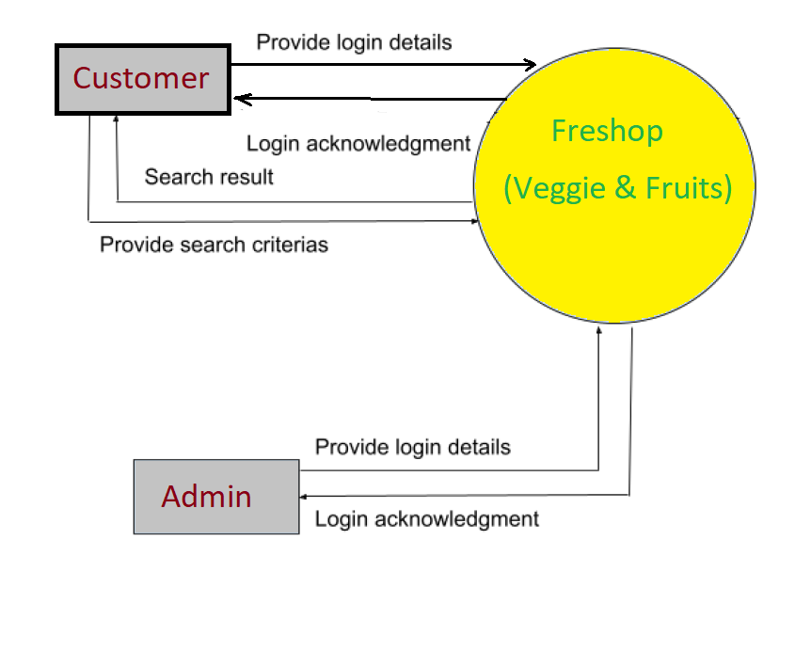

(Oth Level)

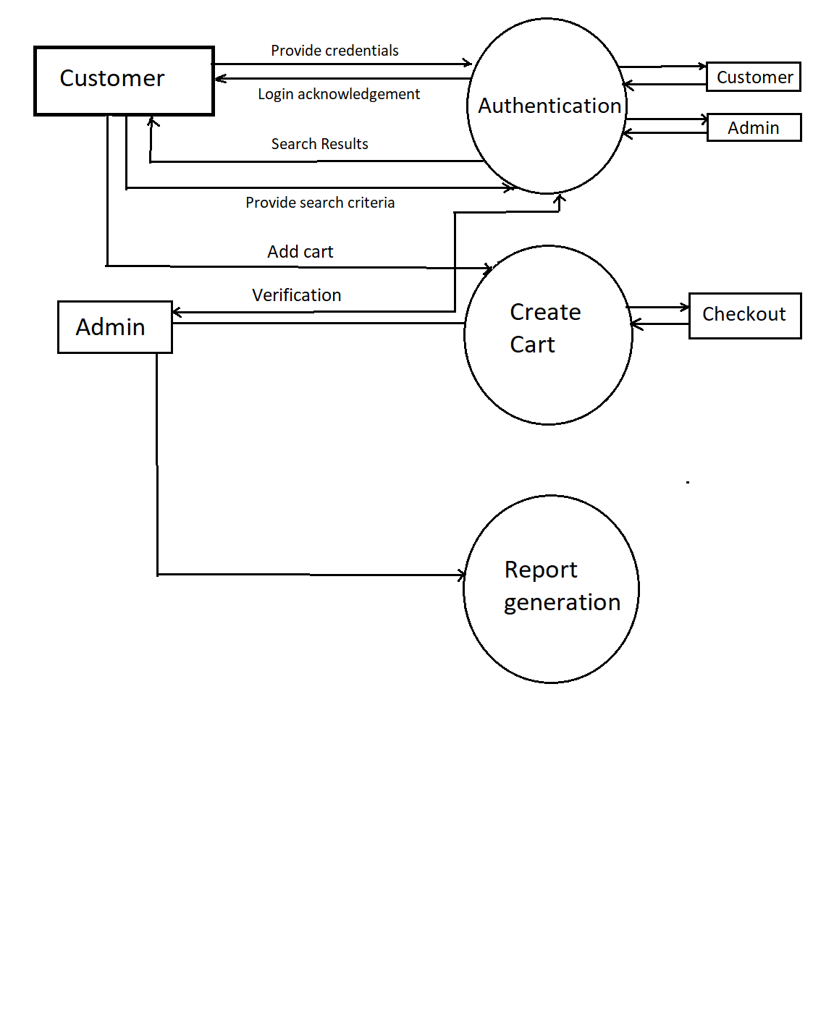

(1st Level)

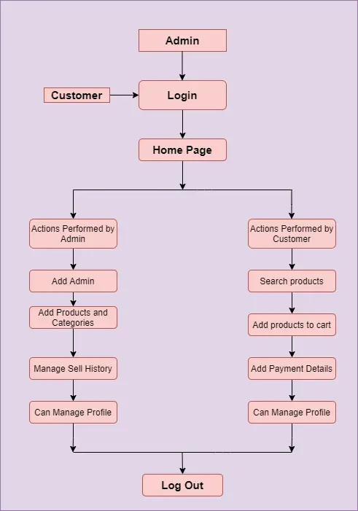

## 5.2 Model Design

The model that is basically being followed is the WATER FALL MODEL, which states that the phases are organized in a linear order. First of all the feasibility study is done. Once that part is over the requirement analysis and project planning begins. If system exists one and modification and addition of new module is needed, analysis of present system can be used as basic model.

The design starts after the requirement analysis is complete and the coding begins after the design is complete. Once the programming is completed, the testing is done. In this model the sequence of activities performed in a software development project are : -

* + - Requirement Analysis
    - Project Planning
    - System design
    - Detail design
    - Coding
    - Unit testing
    - System integration & testing

Here the linear ordering of these activities is critical. End of the phase and the output of one phase is the input of other phase. The output of each phase is to be consistent with the overall requirement of the system. Some of the qualities of spiral model are also incorporated like after the people concerned with the project review completion of each of the phase the work done.

WATER FALL MODEL was being chosen because all requirements were known beforehand and the objective of our software development is the computerization/automation of an already existing manual working system.



**Requirements Engineering**

**Design**

**Programming**

**Maintenance**

**Process**

**Integration**

**Product**

**Product**

**Delivery**

**Input Output**

**Delivered Software Product**

**Integrated Software Product**

**Executable Software Modules**

**Design Specification**

**Requirements Specification**

**Communicated Requirements**

**Changed Requirements**

##### Fig: Water Fall Mode



**5.3 Study Of The System**

**GUI’S**

In the flexibility of the uses the interface has been developed a graphics concept in mind, associated through a browses interface. The GUI’S at the top level have been categorized as

1. Administrative user interface
2. The operational or generic user interface

The administrative user interface concentrates on the consistent information that is practically, part of the organizational activities and which needs proper authentication for the data collection. The interfaces help the administrations with all the transactional states like Data insertion, Data deletion and Date updation along with the extensive data search capabilities.

The operational or generic user interface helps the users upon the system in transactions through the existing data and required services. The operational user interface also helps the ordinary users in managing their own information helps the ordinary users in managing their own information in a customized manner as per the assisted flexibilities.

**CHAPTER 6**

**UML DIAGRAM**



Activity Diagram -

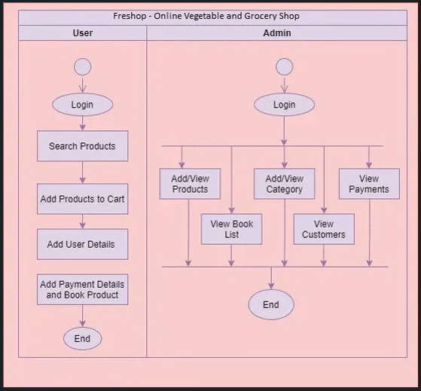

**Admin-**

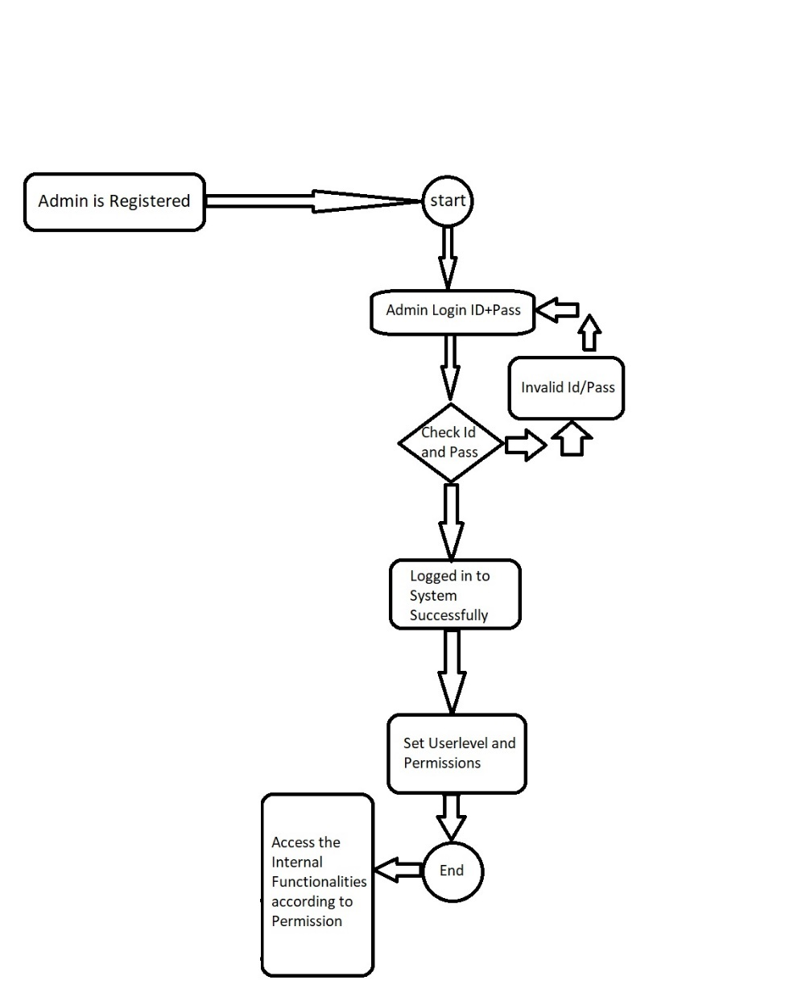

**Supplier -**

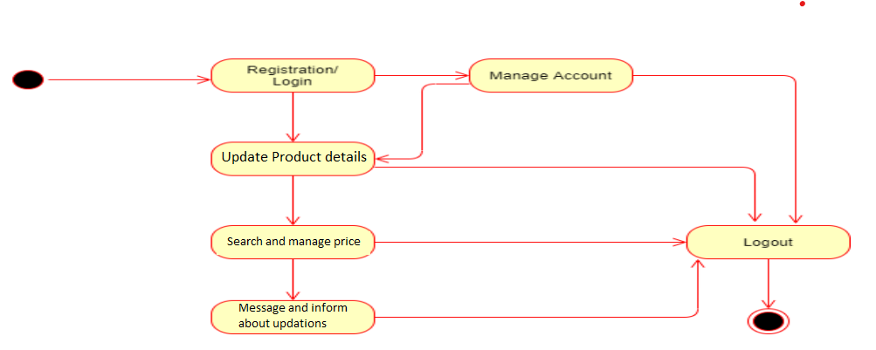

**Customer-**

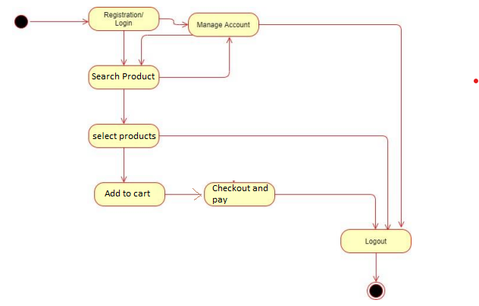

**Sequence Diagram –**

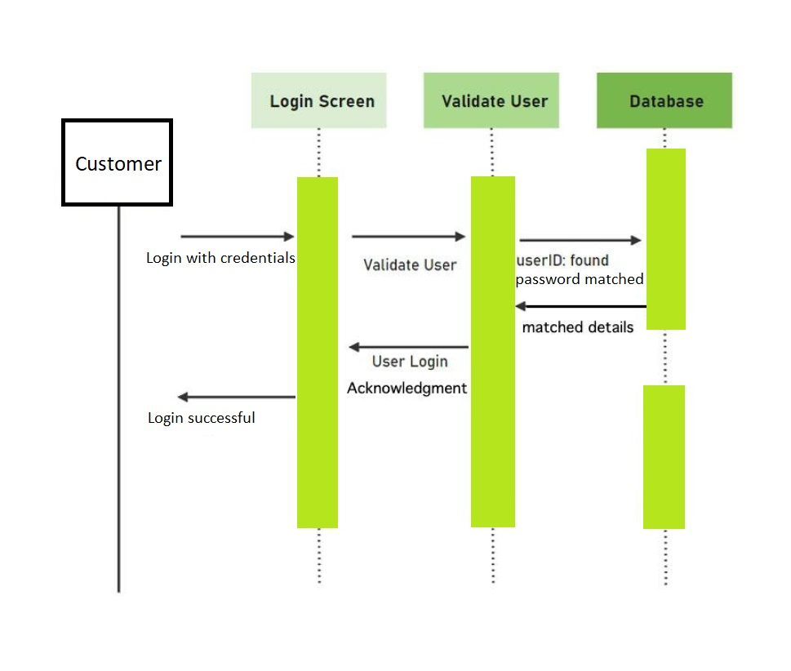

**E-R Diagram –**

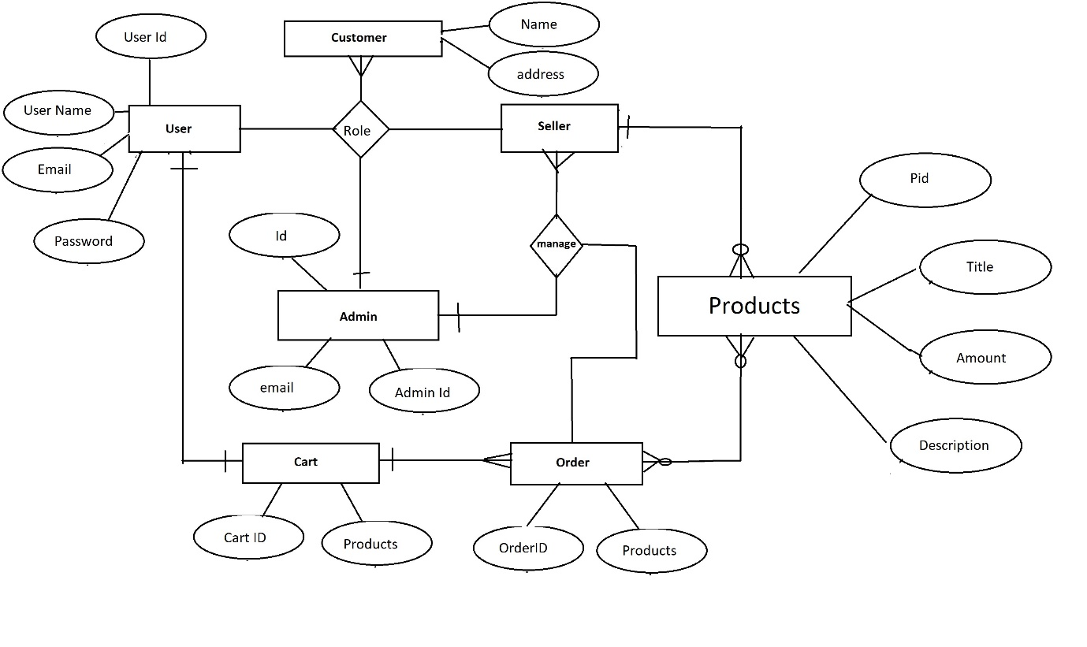

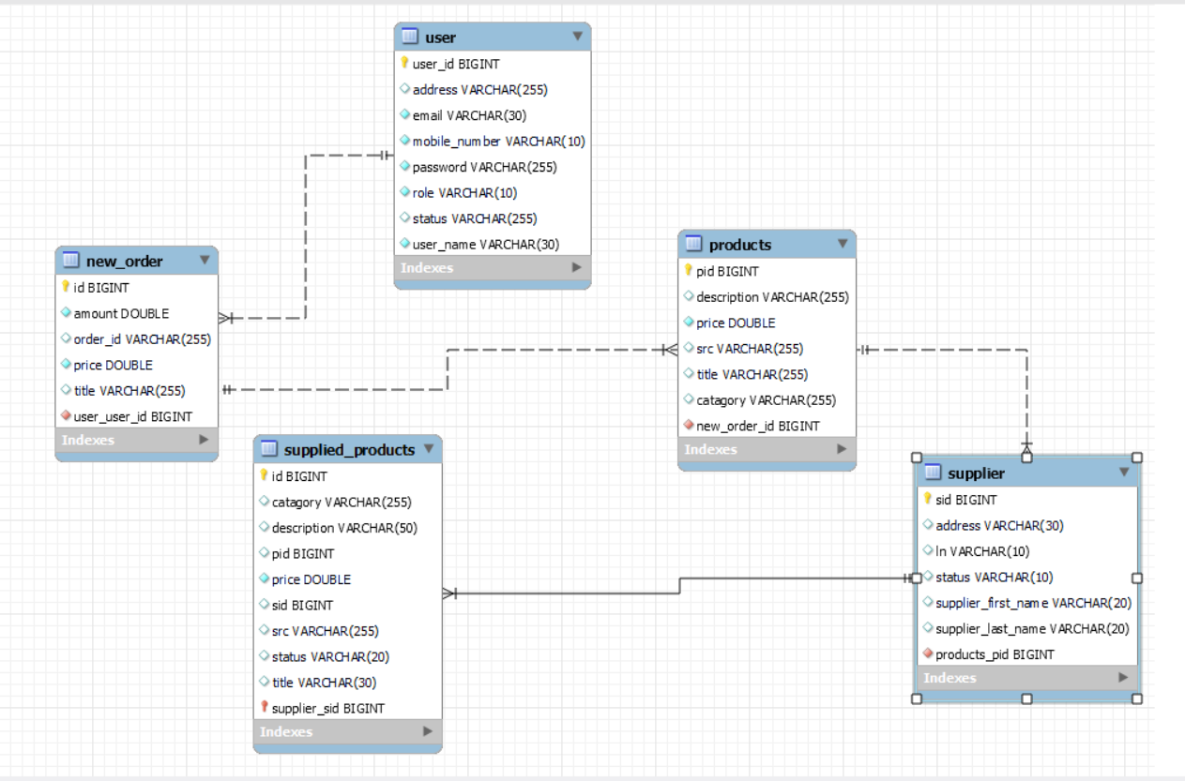

**CHAPTER 6**

**OUTPUT SCREEN**



**Home Screen (Header+carousel)-**

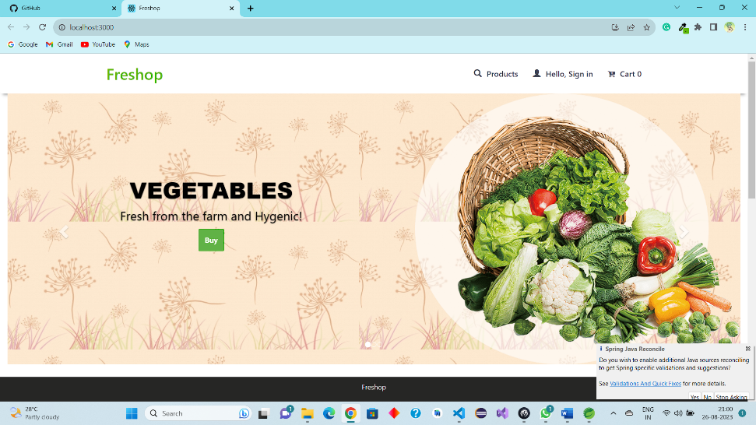

**About section -**

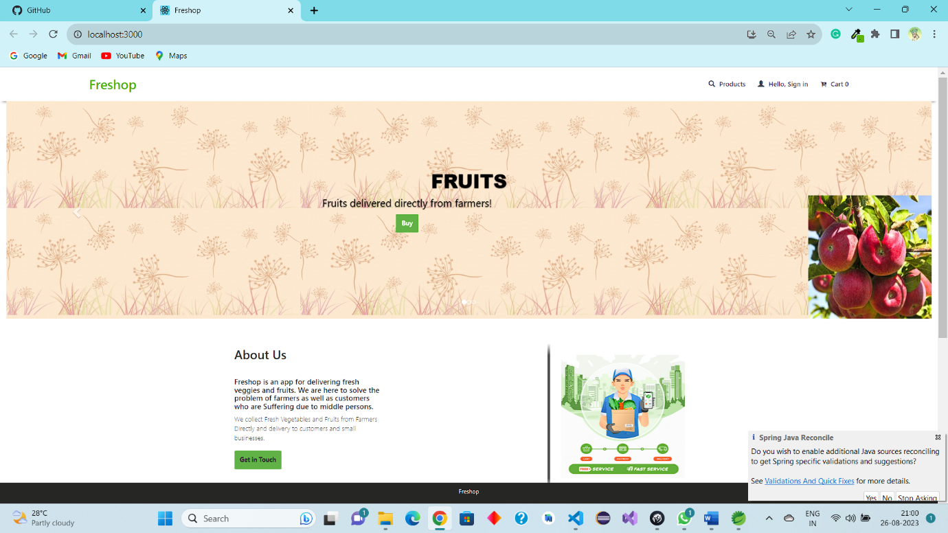

**Product page with cart -**

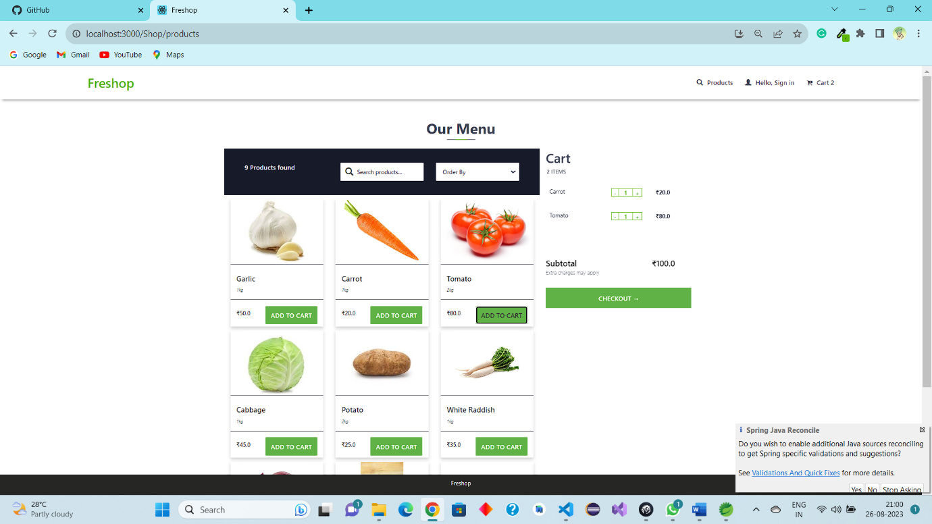

**Sign in page -**

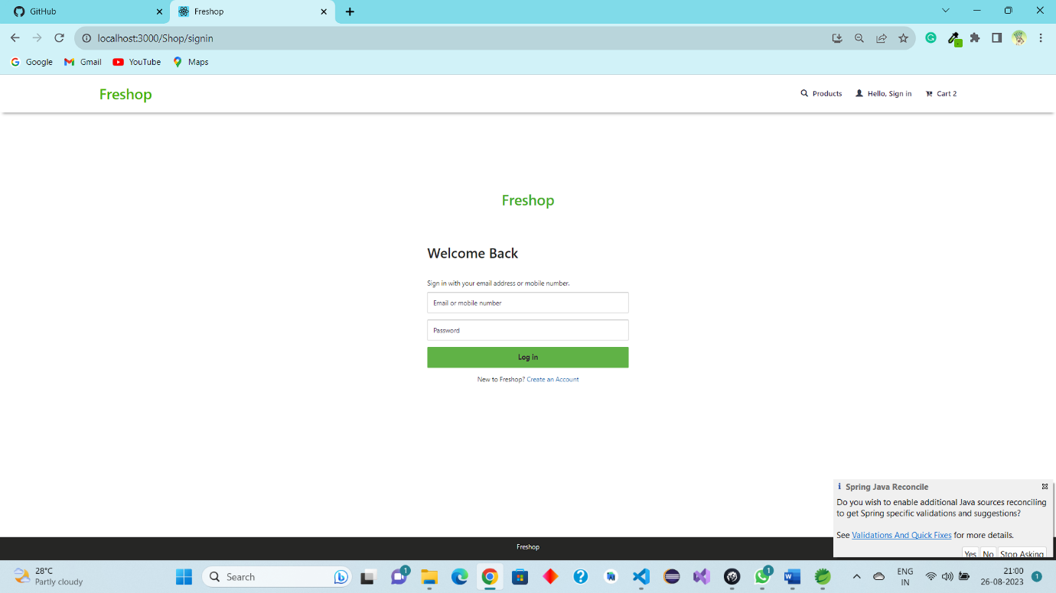

**Sign up page -**

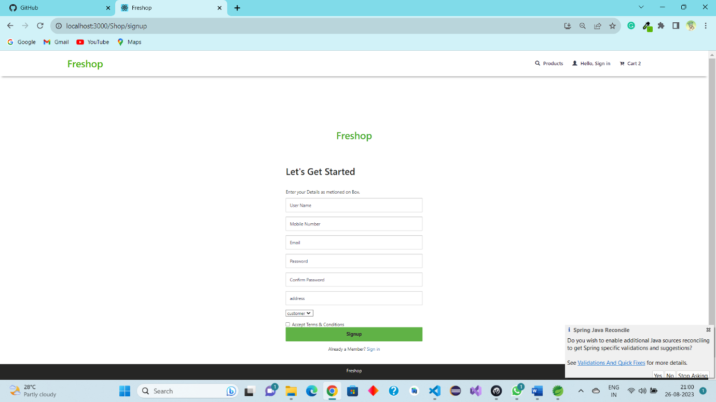

**Admin Page -**

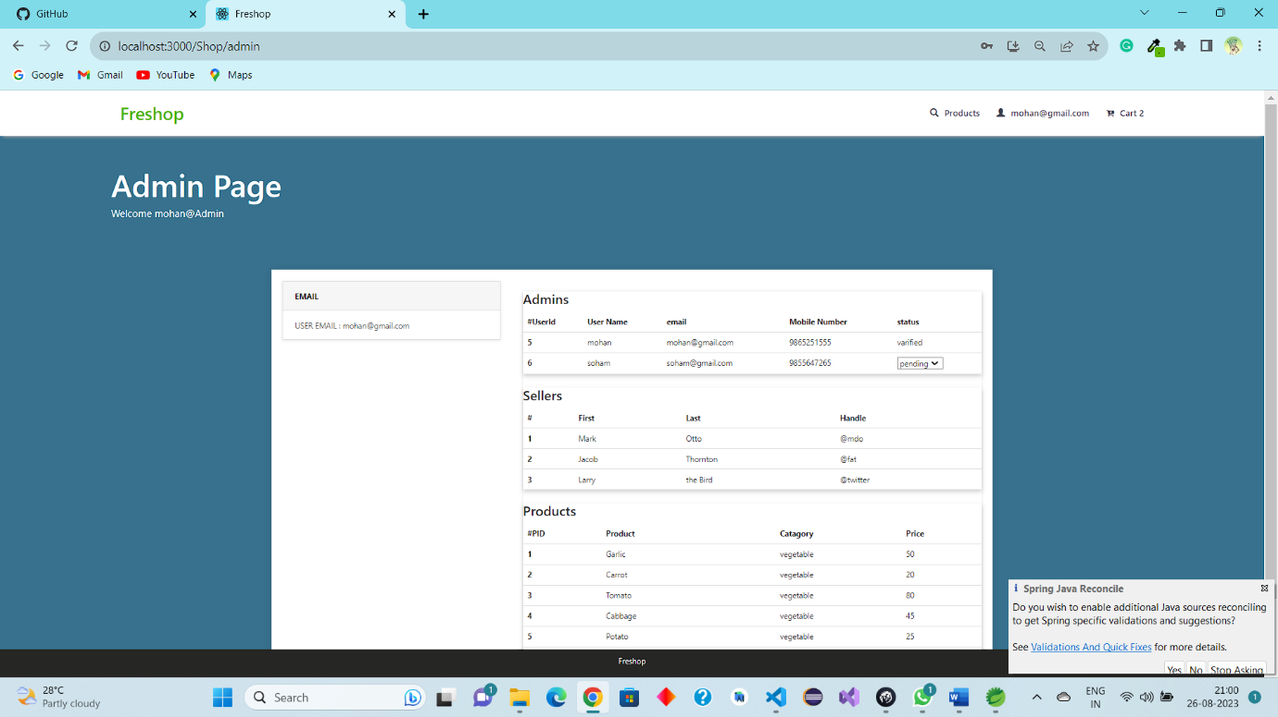

**Supplier Page -**

**Main Supplier-**

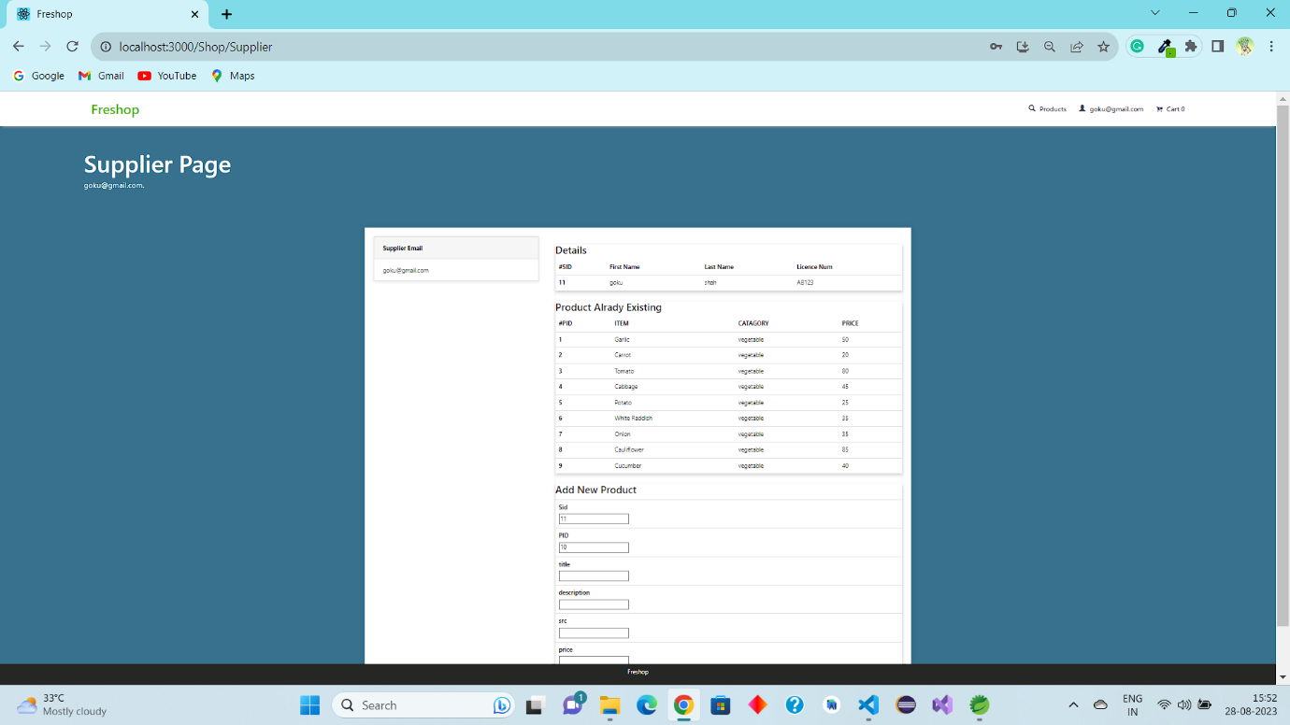

**Supplier Register –**

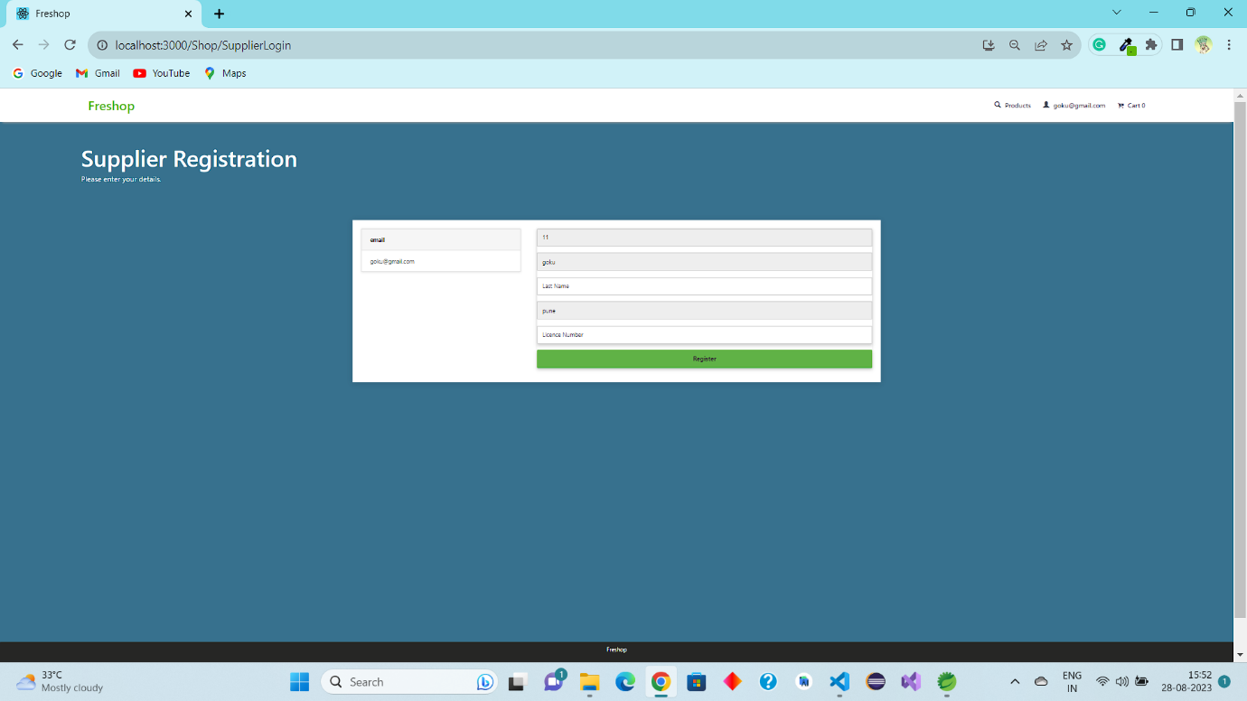

**Check-out -**

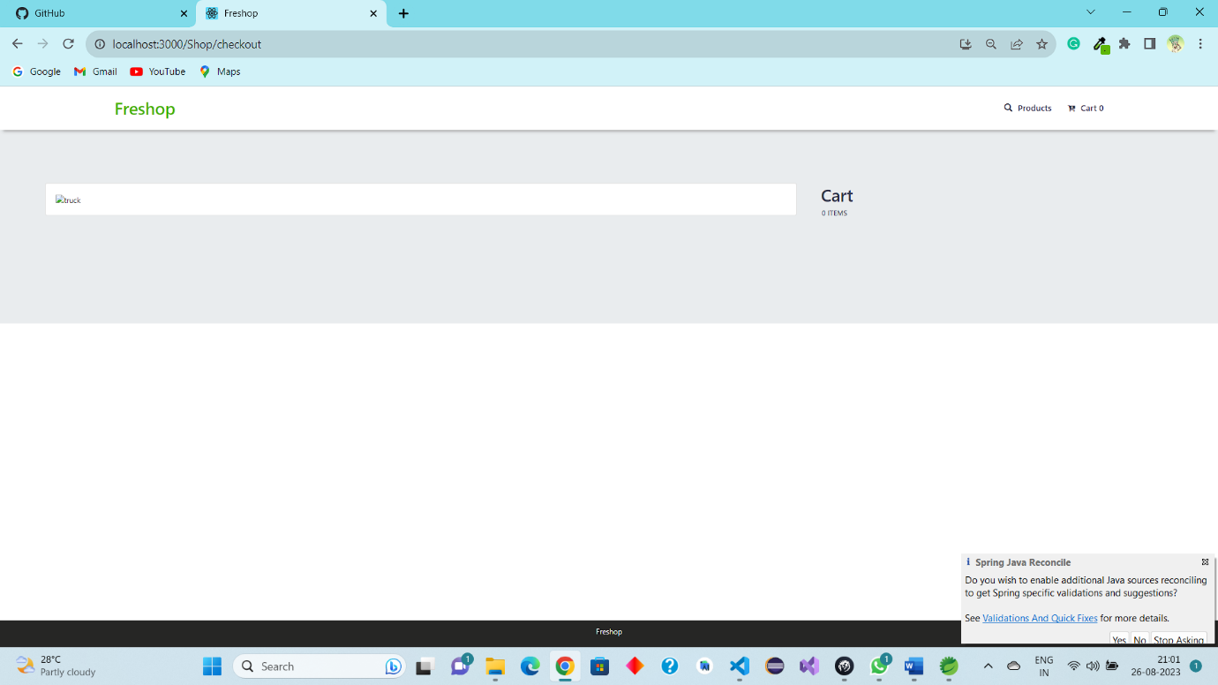

**CHAPTER 7**

**CONCLUSION**



It has been a great pleasure for me to work on this exciting and challenging project. This project proved good for me as it provided practical knowledge of not only programming in Spring and Spring boot web based application and no some extent Windows Application and SQL Server, but also about all handling procedure related with **“Freshop – Online Vegetable and Grocery app”.** It also provides knowledge about the latest technology used in developing web enabled application and client server technology that will be great demand in future. This will provide better opportunities and guidance in future in developing projects independently.

##### BENEFITS:

The project is identified by the merits of the system offered to the user. The merits of this project are as follows: -

* It’s a web-enabled project.
* This project offers user to enter the data through simple and interactive forms. This is very helpful for the client to enter the desired information through so much simplicity.
* The user is mainly more concerned about the validity of the data, whatever he is entering. There are checks on every stages of any new creation, data entry or updation so that the user cannot enter the invalid data, which can create problems at later date.

Sometimes the user finds in the later stages of using project that he needs to update some of the information that he entered earlier. There are options for him by which he can update the records. Moreover there is restriction for his that he cannot change the primary data field. This keeps the validity of the data to longer extent.

* User is provided the option of monitoring the records he entered earlier. He can see the desired records with the variety of options provided by him.
* From every part of the project the user is provided with the links through framing so that he can go from one option of the project to other as per the requirement. This is bound to be simple and very friendly as per the user is concerned. That is, we can sat that the project is user friendly which is one of the primary concerns of any good project.
* Data storage and retrieval will become faster and easier to maintain because data is stored in a systematic manner and in a single database.
* Decision making process would be greatly enhanced because of faster processing of information since data collection from information available on computer takes much less time then manual system.
* Allocating of sample results becomes much faster because at a time the user can see the records of last years.
* Easier and faster data transfer through latest technology associated with the computer and communication.
* Through these features it will increase the efficiency, accuracy and transparency,

##### LIMITATIONS:

* The size of the database increases day-by-day, increasing the load on the database back up and data maintenance activity.
* Training for simple computer operations is necessary for the users working on the system.

**CHAPTER 8**

**REFERENCES**



* [React Tutorial (w3schools.com)](https://www.w3schools.com/react/)
* [Learn Spring Boot | Baeldung](https://www.baeldung.com/spring-boot)
* [Spring Data JPA - Reference Documentation](https://docs.spring.io/spring-data/jpa/docs/current/reference/html/)
* [React – A JavaScript library for building user interfaces (reactjs.org)](https://reactjs.org/)
* Bootstrap · the most popular HTML, CSS, and JS library in the world. (getbootstrap.com)